Outcomes of Fontan Surgery in a Developing Country
Laraib Javed 1, Rubab Mansoor 2, Muneer Amanullah (corresponding author)
Speaker: Laraib Javed
Aga Khan University Hospital, Karachi Pakistan

Introduction & Objectives
Pakistan's population has risen to a booming 207.77 million; with it the incidence of congenital heart disease has also increased.Pakistan has one of the highest prevalence of children born with CHD in the world. Each year around 40-50,000 children are born with heart defects one of which is Single Ventricle Physiology. Untreated Single Ventricle physiology carries a very poor prognosis with the highest risk of mortality in comparison to other CHD.The treatment for single ventricle involves a series of palliative surgeries which finally culminates in the Fontan surgery with the objective of creating a direct connection between the vena cavae and the pulmonary arteries and thus ensuring adequate blood supply to the lungs and the body.
The median age for this surgery in the west is generally early ranging around 1.7–4.8 yrs and the median age for this surgery in Athens,Greece is around 5.7 years. In Pakistan due to dearth of awareness and resources patients generally present to the hospital at a later stage with ages of patients ranging from 2.6 -21 yr presenting to Aga Khan University Hospital from the past year alone. There is also a scarcity of research done on Fontan surgery in Pakistan which is paramount to understand and reflect back on the outcomes of this surgery performed here in Pakistan.
This study therefore serves to assess the overall outcome and success of the Fontan operation that took place at Aga Khan University Hospital. It will also serve to compare and contrast our results with those found world wide. This study will serve as a stepping stone in the road to fill the vast gap left by the scarcity of research on this topic in Pakistan.

Methods
A retrospective case series is conducted. Patients undergoing the Fontan Operation at the Aga Khan University Hospital; Karachi, Pakistan are included from January ( October) 2014 to December 2017.
Exclusion criteria includes operations performed in the absence of Right Heart Catheterization and for Fontan operations performed outside of Aga Khan University Hospital. Note is taken of preoperative and postoperative variables. The data is analysed using Statistical Packaging for Social Sciences (SPSS) version 20.

Results
25 patients underwent Fontan surgery at Aga Khan University Hospital of which data of 18 patients could be retrieved. The 18 patients who underwent the Fontan operation 6 (33.3%) were female and 12 (66.7%) were male.15 underwent two stage TCPC and 3 underwent one stage TCPC with the formation of exctracardiac PTFE (polytetrafluoroehylene) conduit. Mean age at operation was 8.5±4.60years.
6(33.3%)had undergone multistage palliation (stage I and II), while 9 (50%) had prior bidirectional cavopulmonary shunt (stage II). One patient (5.6%) had a PDA shent placed prior to the bidirectional cavopulmonary shunt. Blalock Taussing shunt was performed in all the patients that underwent stage I palliation and in 1 patient prior to one stage TCPC.
The mean total pulmonary vascular resistance of the patients was 1.2±0.609wu. The mean pulmonary arterial pressure was 13.1±2.08 mmHg.The LVEDP was below 15mmHg in all the patients with values ranging from 7-13 mmHg. The mean haemoglobin concentration was 16.8±10.6 g/dl.All the patients had normal sinus rhythm preoperatively.
Variables | Mean | Range
Age (Years) | 8.5 | 2.67-21
Weight (kg) | 23.4 | 10.5-50
Height (cm) | 115.8 | 63-160
BSA | 0.8 | 0.49-2
Table1:Demographics

Table 2:
Procedures
Procedure | Extra cardiac TCPC: 18
Additional procedure | Fenestrations: 15  LPA plasty: 1  PDA ligation & division: 2  Atrial Septectomy:2

Mean bypass time was 147.2±50.183 minutes, Aortic cross clamp was used in 7 patients with mean time of 30.3±40.318 minutes and the mean minimum temperature was 30.9°C ±3.47. Mean operation time was 5.6± 1.07 hrs Fenestration was performed in 14 (77.8%) patients.
Intraoperative complications included one case of LMCA injury. Operative mortality was 0%. The most frequent post operative complication was prolonged pleural effusion. Mean duration of pleural effusion was 12.7±7.19 days. Mean pre-operative oxygen saturations were 73.4±9.69 which significantly increased to 83.0±9.36 post-operatively.
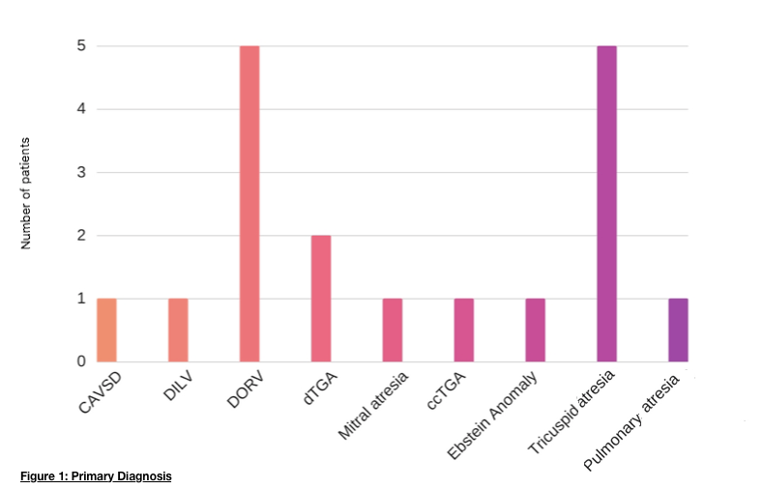

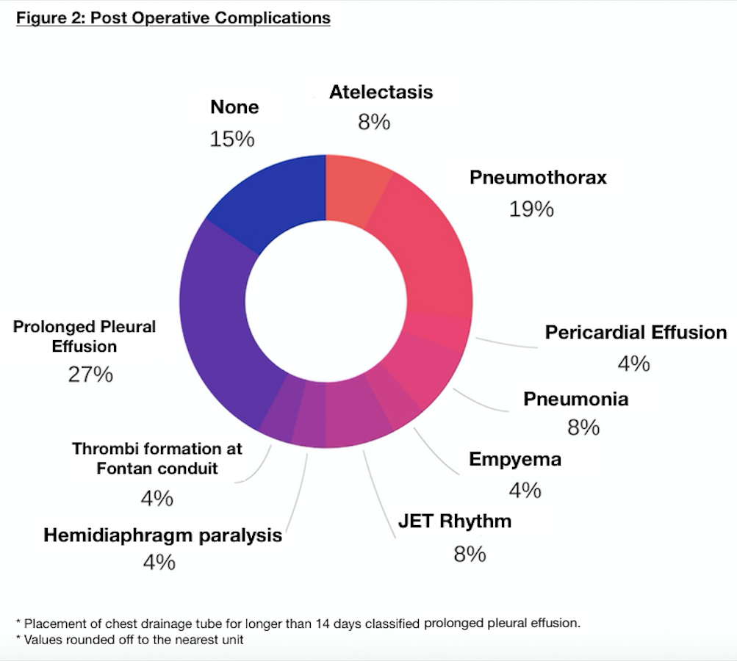

Post operative complications were seen in 14 patients. Thrombi formed in one patient measuring 7x7 mm in Right Atrium Fontan Conduit which was treated with anti coagulant therapy. The LPA stenosis persisted in the patient who underwent LPA plasty.

Variables: | Mean | Range
Pleural drainage duration (days) | 12.7± 7.19 | 6-32
Intensive care stay duration (days) | 6.8±3.07 | 2-13
Ventilation time (hrs) | 31± 39.993 | 0-155
Hospital stay duration (days) | 12.3±4.31 | 8-23
Ejection fraction (%) | 50.6± 20.45 | 35-80
In Hospital mortality (%) | 0
Peripheral capillary oxygen saturation (%) in outpatient clinic post surgery | 83±9.36 | 70-98
Table 3:Outcomes

Conclusions:
The median age at which this surgery is conducted is significantly higher in our setting with a median of 7.5 years compared to those cited by other international research papers; we also had a higher percentage of patients who underwent fenestration (77.8%) and also had a higher mean ICU stay (6.8 days) and mean ventilation time (31 hrs) with a comparable time for placement of chest tube for drainage along with bypass and aortic cross clamp time. Despite these differences our results showed that The Fontan Procedure can be performed safely at Aga Khan University Hospital with consistent results.
The limitations of this study included the small sample size and the retrospective nature of the study. Lack of long term follow up of these patients owing to most patients not belonging to the city of Karachi is also a hindrance to our research.
The need of the hour is now to increase the database of patients undergoing Fontan surgery at AKUH and to conduct similar researches in other medical centres of Pakistan so as to better understand the implications of this surgery and hence to optimise the results of the Fontan Procedure.

